Testmaker 9.3

Chapter 9 Energy transmission Name: ___________________________

 | Identify the correct statement about reflection of light.  - The angle of incidence equals the angle of refraction.  - The reflective coating is commonly placed on the back surface of a plane mirror.  - The law of reflection only applies to plane mirrors.  - Parallel rays of light are reflected to a focal point in a convex mirror. | B | 1
 | Which material can be classified as translucent?  A Red cardboard  B Window glass  C Frosted glass  D Carpet | C | 1
 | Which of the following is not an example of electromagnetic radiation?  - Light  - Microwaves  - Sound  - Ultraviolet radiation  - X-rays | C | 1
 | Which statement applies to all waves?  - Can move through a vacuum  - Carry energy  - Involve electric and magnetic fields  - Travel faster in solids | B | 1
 | Through which of the following materials does light travel with the greatest speed?  - Water  - Glass  - Air  - Diamond | C | 1
 | The waves of the electromagnetic spectrum with the shortest wavelength are:  - radio.  - infra-red.  - X-rays.  - gamma. | D | 1
 | The coloured part of the eye is the:  - iris.  - cornea.  - retina.  - sclera. | A | 1
 | Which of the following types of waves are examples of radio waves?  - Infra-red radiation  - Microwaves  - Sound waves  - Ultraviolet radiation | B | 1
 | Which of the following methods of long-distance communication cannot be used without artificially produced electromagnetic radiation?  - Co-axial cable  - Mail  - Optical fibres  - Telegraph | C | 1
 | Which of the following is a not a digital device?  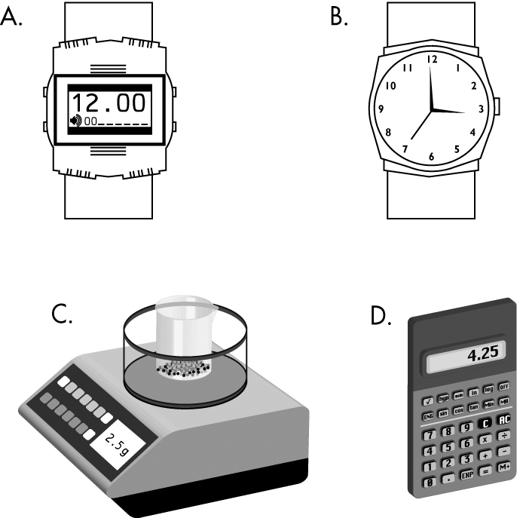 | B | 1
 | A surface that absorbs light is said to be:  - opaque.  - transparent.  - optically dense.  - translucent. | A | 1
 | The speed of radio waves in air is closest to:  - 100 m/s.  - 186 000 m/s.  - 300 m/s.  - 300 km/h.  - 300 000 000 m/s. | E | 1
 | Which of the following measures the wavelength of a transverse wave?  - The distance between the top of a crest and bottom of a trough  - The distance of the top of a crest above the bottom of a trough  - The distance from the start of a wave to its end  - The distance between the bottoms of two troughs | D | 1
 | Optical fibres are used in communication systems to carry:  - high frequency light pulses.  - electrical signals.  - AC current.  - microwaves and sound waves. | A | 1
 | Light pulses can be sent long distance along glass fibres without leaving the glass as a result of:  - the transparency of glass.  - the high speed of light.  - total internal reflection.  - the absorption of light. | C | 1
 | Which of the following shows different types of waves in order of increasing frequency?  - AM radio, FM radio, infra-red radiation, visible light, ultraviolet radiation, X-rays  - Visible light, AM radio, FM radio,  infra-red radiation, X-rays, ultraviolet radiation  - Microwaves, X-rays, FM radio, AM radio, ultraviolet radiation, infra-red radiation  - Gamma rays, X-rays, ultraviolet radiation, visible light, infra-red radiation, FM radio | A | 1
 | Television signals are transmitted on:  - AM radio waves.  - FM radio waves.  - both AM and FM radio waves.  - neither AM nor FM radio waves. | C | 1
 | The most optically dense natural material is:  - diamond.  - quartz.  - glass.  - emerald. | A | 1
 | Which of the following methods of communication can carry the biggest number of two-way conversations at once?  - Copper cable  - Coaxial cable  - The microwave link  - Optical fibres | D | 1
 | Which of the following long distance communication methods use repeater stations? (More than one answer.)  - The microwave link  - Coaxial cables  - Optical fibres  - Earth-satellite radio waves | A, B, C | 1
 | In which part of a synchrotron are electrons accelerated to 99.9987% of the speed of light by a high voltage electric field?  - Storage ring  - Booster ring  - Linac  - Beamline | C | 1
 | Why is it not possible for sound to travel through the vacuum of outer space? | There are no particles to push together or spread apart. | 2
 | Use a diagram to show the difference between a compression and a rarefaction. | 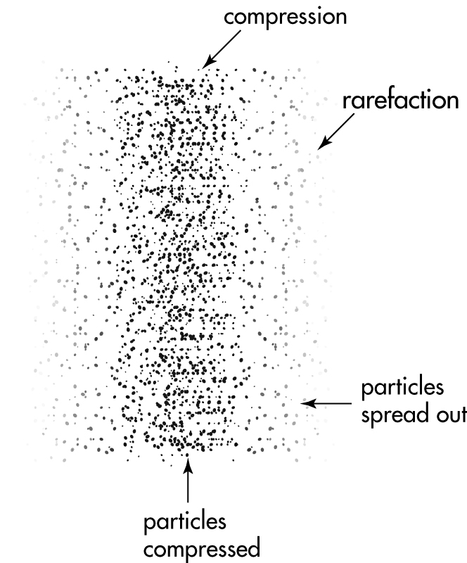 | 2
 | Parallel rays of light are incident on a convex and a concave mirror. Draw diagrams to show the paths of the reflected rays. | Convex:  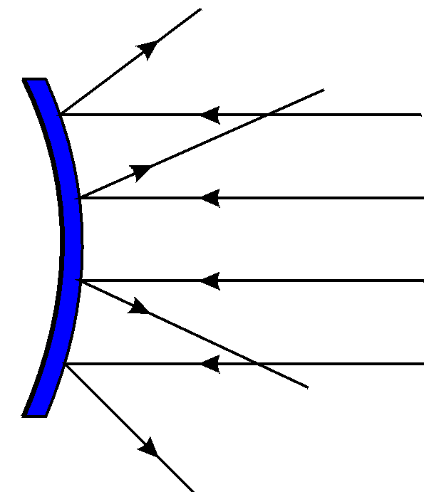  Concave:  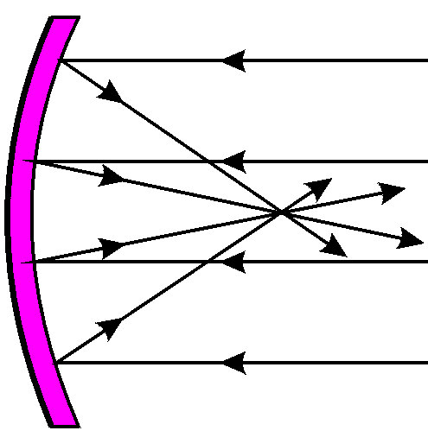 | 2
 | Draw a diagram of an optical fibre to show how a light ray moves through the fibre. | 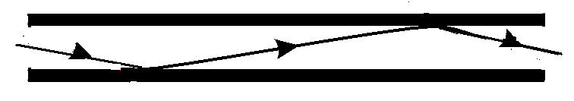 | 2
 | Copy and complete the following diagram to show the refraction of the light ray.  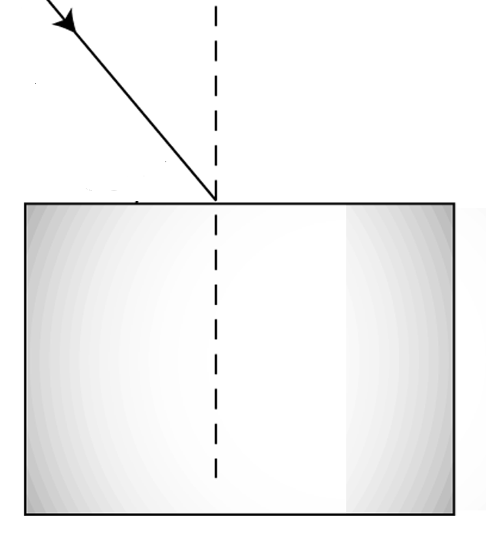 | 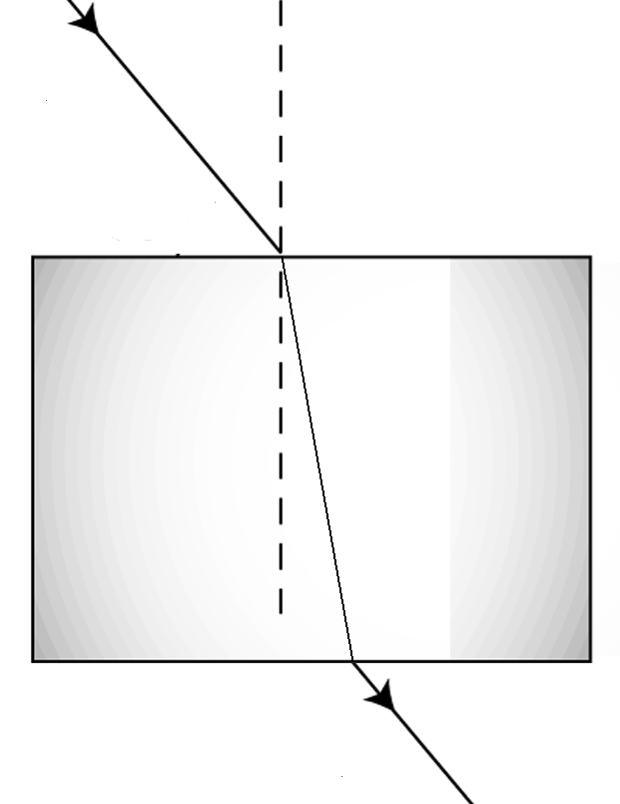 | 2
 | List one use of each of the following types of waves.  - Microwaves  - Infra-red radiation  - X-rays  - Gamma rays | - Any one of the following: cooking, communication.  - Any one of the following: remote controls, remote sensing from satellites  - Any one of the following: seeing through human flesh, killing cancer cells, detecting weaknesses in metals, chemical analysis  - Any one of the following: killing cancer cells, detecting weaknesses in metals | 4
 | White light is composed of a spectrum of colours. White light strikes a green box as shown. Complete the diagram to show the reflected light.  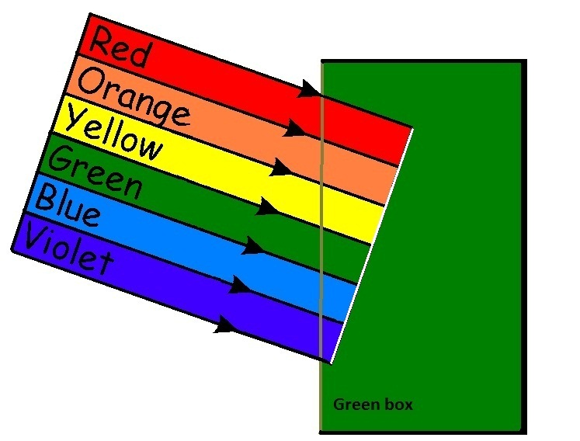 | 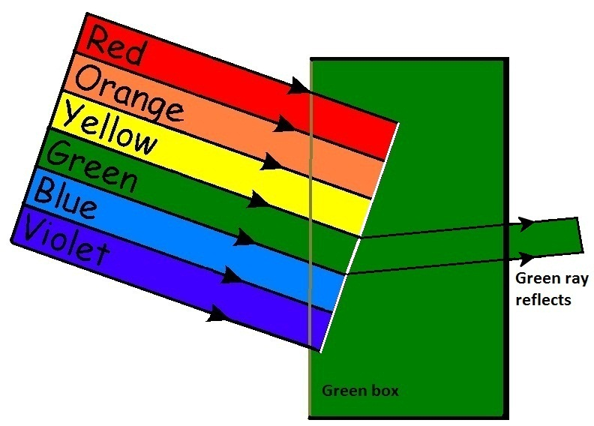 | 2
 | Are electromagnetic waves transverse waves or compression waves? State a reason for your answer. | Transverse. The electric and magnetic forces that they are made of are at right angles to the direction of motion. | 2
 | Complete the labelling of the eye diagram.  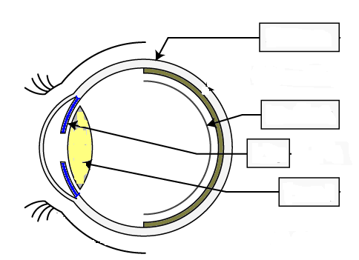 | 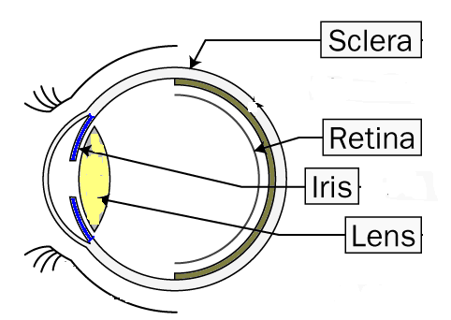 | 4
 | A radio wave has a speed of 300 000 000 m/s and a wavelength of 10 m. Calculate the frequency of the radio wave in MegaHertz (MHz). | v =f.λ  f = v/λ = 300 000 000/10 = 30 000 000 Hz  = 30MHz | 2
 | Complete the diagram of the electromagnetic spectrum by naming the remaining bands.  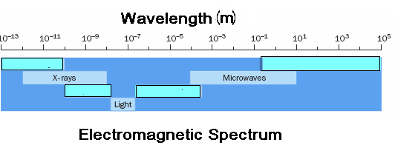 | 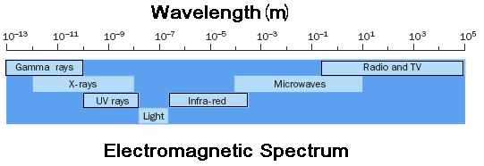 | 4

